32 Bit MIPS Processor using Pipeline
Implementation
ARCHITECTURE
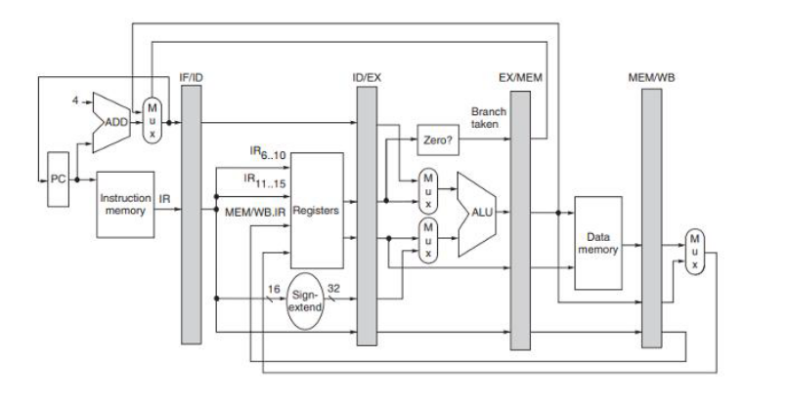
PIPELINE STAGES
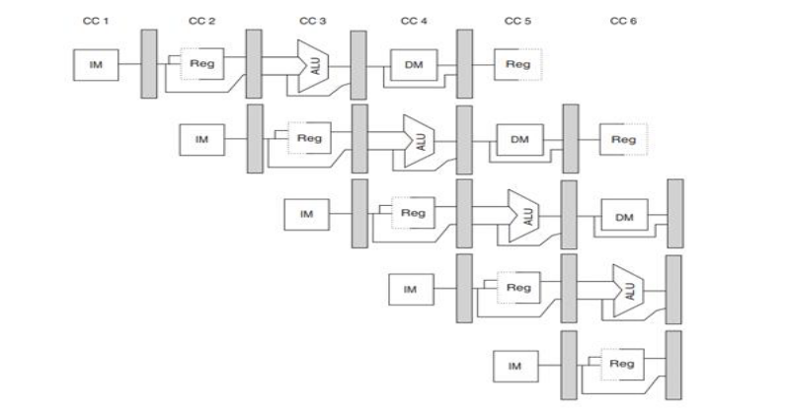
32-BIT MIPS PROCESSOR WITH A PIPELINED ARCHITECTURE
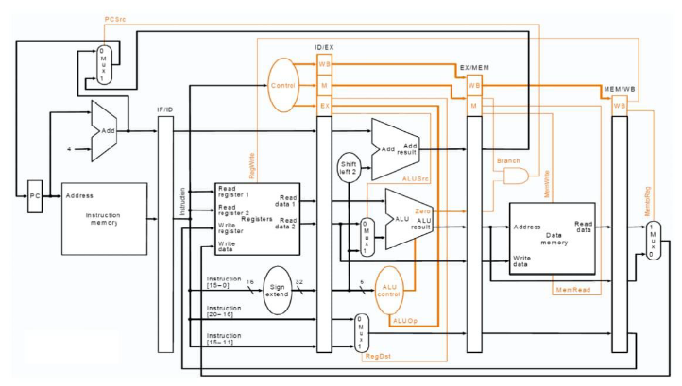

HAZARD HANDLING MECHANISM
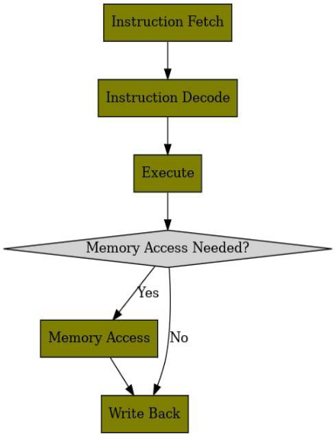

SIMULATION AND VERIFICATION
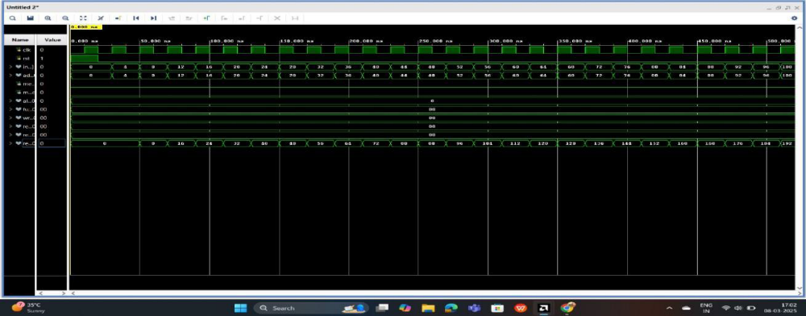

POWER ANALYSIS
